**CHAPTER THREE**

**RESEARCH METHODOLOGY**

**3.0 Introduction**

This chapter shows how the research methods used in carrying out the research in line with the research procedure. The aim is find out the appropriate design for poultry management system. And establish what methods employers, recruiters and organizations use during verification of certificates

The information obtained from the review was used to influence in the development of the system for certificate verification.

## 3.1 Software Development Life Cycle (SDLC)

## SDLC stands for software development life cycle. A software development life cycle is essentially a series of steps or phases that provide a model for the development and life cycle management of an application or piece of software. The methodology within the SDLC process can vary across industries and organizations, but standards such as ISO/IEC 12207 represent processes that establish a life cycle for software and provide a mode for the development, acquisition, and configuration of software systems.

## 3.1.1 Chosen Methodology

## The chosen methodology for development of this system is the Water-Fall . Model which is the oldest and the most widely used paradigm for software engineering. This model provides a systematic and sequential approach to software development. It is very useful where the requirements are well understood. This model is chosen because of the reasons stated below:

* easy to explain to the users
* structured approach.
* stages and activities are well defined.
* helps to plan and schedule the project.
* verification at each stage ensures early detection of errors/misunderstanding.

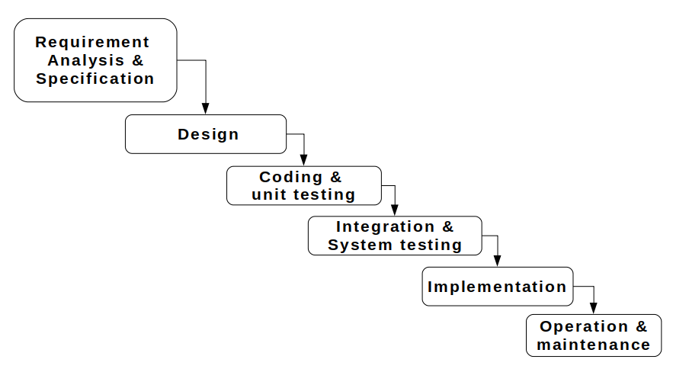**Figure 3.1**: waterfall model

* + - 1. **Requirement analysis and specification phase**

The goal of this phase is to understand the exact requirements of a proposed system and to document them properly. This activity is usually executed together with the client, as the goal is to document all functions, performance and interfacing requirements for the software. The requirements describe the “what” of a system not the “how”. This phase produces a large document, written in natural language, contains a description of what the system will do without describing how it will be done. The resultant document is known as software requirement specification (SRS) document.

**Method of Data Collection**

During this project research work, data needed for the project was gathered from the various sources. In gathering and collecting necessary data and information needed for the successful completion of this project, two major fact-finding techniques were used in this work and they are:

**Primary source**

This refers to empirical approach; the form of collecting data was made in form of interviews conducted in ECWA farms, and Alheri Polutry. ECWA and Alheri farms undergoes a manual system of record management in the farm whereby all the activities of the farm are recorded in paper.

**Secondary Source**

The secondary data were obtained through reviews from journals and the internet.

1. **Design phase:** when the SRS document is produced in the previous phase, which contains the exact requirements of the proposed system. The goal of this phase is to transform the requirements specification into a structure that is suitable for implementation in some programming language. Here, overall software architecture is defined, and the high level and detailed design work is performed. This work is documented and known as software design description (SDD) document. The information contained in the SDD should be sufficient to begin the coding phase. Several tools and techniques were used for designing. The tools and techniques includes: Flowchart and Use Case Diagram etc.

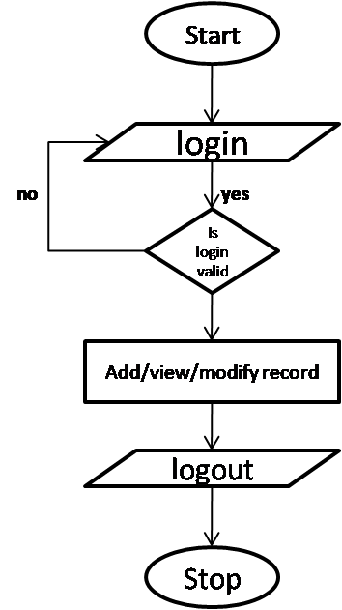

**Figure 3.2:** flow chart of the system

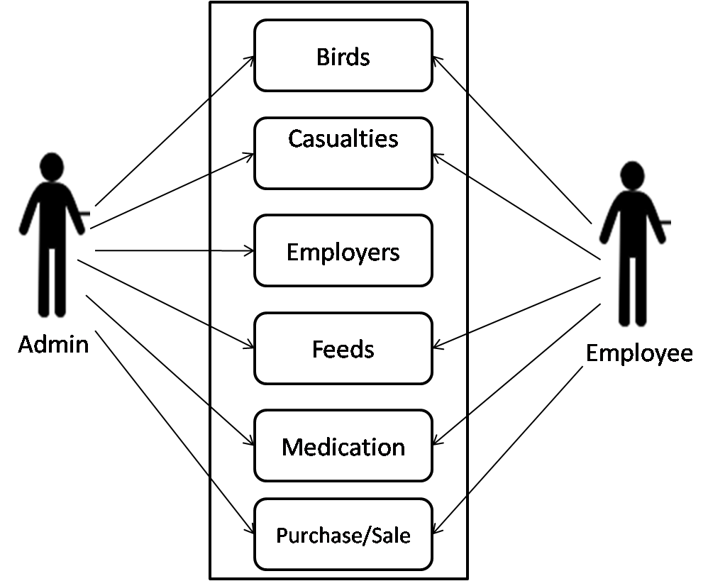

**Figure 3.3:** use case diagram of the system

1. **Coding and Unit testing:** During this phase coding proceeds smoothly because all the information needed by the software development is contained in the SDD. The main purpose of this phase of waterfall model is to translate the software design into source code. The end product of this phase is a set of program modules.
2. **Integration and system testing:** This is very important phase. Effective testing will contribute to the delivery of higher quality software products, more satisfied users, lower maintenance costs and more accurate and reliable results. During this phase individual program units or programs are integrated and tested as a complete system to ensure that software requirements have been met. After system testing, the software is delivered to the customer.
3. **Implementation:** This is the process in which the developed system is handed over to the client.
4. **Operation and maintenance:** Software maintenance is a task that every development group has to face, when the software is delivered, installed and is made operational. Therefore, release of software inaugurates the operation and maintenance phase of the life cycle. The time spent and effort required keeping the software operational after release is very significant. Despite the fact that it is a very important and challenging phase.
   1. **Tools used for the system development**

**Python:** is an interpreted, high-level, general-purpose programming language. Created by Guido van Rossum and first released in 1991

**PostgreSQL:** also known as Postgres, is a free and open-source relational database management system (RDBMS) emphasizing extensibility and technical standards compliance. It is designed to handle a range of workloads, from single machines to data warehouses or Web services with many concurrent users.

**Django:** is a high-level Python Web framework that encourages rapid development and clean, pragmatic design.

**ORM:** Object-Relational Mapping is a technique that lets you query and manipulate data from a database using an object-oriented paradigm

**HTML:** is the standard markup language for creating Web pages. HTMLstands for Hyper Text Markup Language. HTMLdescribes the structure of a Web page.

**CSS:** stands for Cascading Style Sheet. Is a style sheet language that describes the presentation of an HTML document. CSS describes how elements must be rendered on screen, on paper, or in other media.

**JavaScript: JavaScript is the programming language of HTML and the Web it** is a lightweight interpreted or just-in-time compiled programming language with first-class functions

**Bootstrap:** it is a free and open-source HTML and CSS framework directed at responsive, mobile-first front-end web development. It contains HTML and CSS based design templates for typography, forms, buttons, navigation and other interface components

**Heroku**: is a container-based cloud Platform as a Service (PaaS). Developers use Heroku to deploy, manage, and scale modern apps

**3.3 Justification for the tools used**

The system as a whole is composed of three (3) parts – the user interface, the application and the database. All of which are integrated and worked together to achieve the specified goal. The hosting platform chosen is Heroku for deploying the system.

The user interface is what the user sees and interacts with the system. The tools used in this part are HTML, CSS, JavaScript and Bootstrap. HTML is used in creating the web pages and the components. CSS is used in styling and positioning the components, and JavaScript is used in handling actions and interactions. Bootstrap is a user interface framework that comprises of HTML, CSS and Bootstrap there by making it simpler in designing the user interface. The tools chosen are the only and best for designing the user interface.

The application is the part that takes the action of all the system operations between the user interface and the database. Therefore it sits in between the two and acts like a middle-man in query the database and sending the response to the user interface. Django is the framework that is chosen for this part, which is based on the python programming language. Python is a high level programming language that is known for its general-purpose use. Django as a framework is known for its security and scalability.

PostgreSQL is a very powerful database system that is based on relational database systems. Relational database systems are the best kinds of system used for handling multiple records in a database. PostgreSQL is also known for its security and the ability to accommodate large records.

For a system to be online and accessible on the World Wide Web, it has to first be deployed. Considerations of the ease of use and cost of deployment make Heroku to be chosen.

**3.4 ANALYSIS OF THE EXISTING SYSTEM.**

the existing system that has been used or in operation in the farm is a manual system, a lots of records have been missing, some intentionally damage and others are damage due to improper information management system. A lot of challenges are been face by the management in keeping proper records of the farm.

The need arise of a computerized management information system that will help keep and provide proper records of all the birds, feeds, eggs, staff and track all records of sales in the farm. Management information system remain the system that aim at providing information for the management on a regular basis.

Management always aim at reading the climax in the decision performance fort attainment of organizational objectives but the existing system could not attract such performance due to the lack of effective information tool which can provide the management with quality and needed information and at needed time.

This system always result to information over local which actually decreases the decision performance in any management.

**3.5 PROBLEMS OF THE EXISTING SYSTEM.**

They say information is power . Quality information is very vital do check in organization. Many poultry farmers still make use of the manual approach of keeping farm records. The consequence of this approach are it is time consuming, needed information may easily be misplaced, un-organized and inefficient. Also, needed reports concerning different aspects of the farm cannot be easily retrieved when needed.

This situation makes it to monitor the state of the birds in the poultry, income and expenses and other relevant information. To overcome these problems there is need for an information system for proper management of the poultry farm.

the only information that can accelerate the management decision performance is the information that process the good quality of information. the problems of the existing system are

1. Accuracy
2. Reliability
3. Relevance
4. Completeness
5. Timeliness

Due to the show mentioned problems and errors associated with the existing system, an alternative system is suggested which is a computerized system.

**3.6 JUSTIFICATION OF THE NEW SYSTEM**

1. To automate the manual means of recording poultry farm records.
2. To develop a database application that can be used to maintain and provide information about the livestock and financial information aspect of the poultry farm
3. To provide a system that can facilitate the update of poultry farm records
4. To develop a system that will aid the presentation of reports pertaining the poultry farm
5. To facilitate in fast decision making in the farm.